CE3003 Project

Note App

Features:

Show Note

Create Note

Delete Note

Edit Note

**Inside The App**

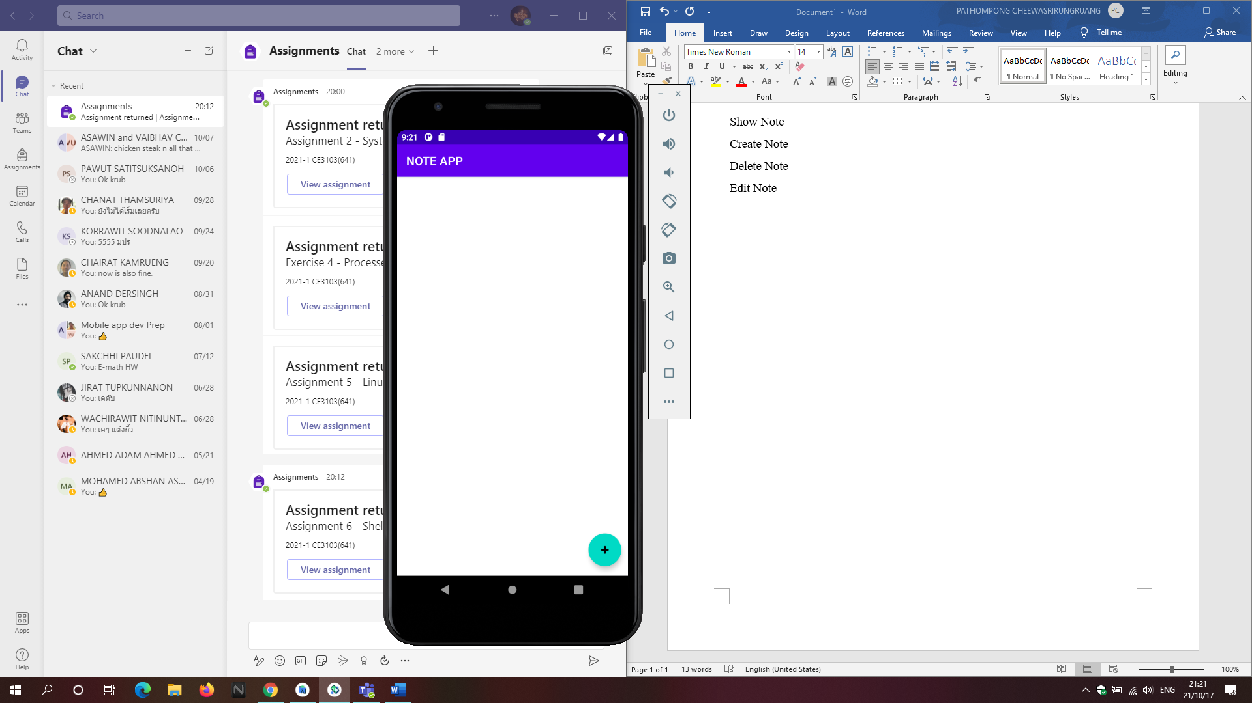

**After Pressing the Floating Action Button**

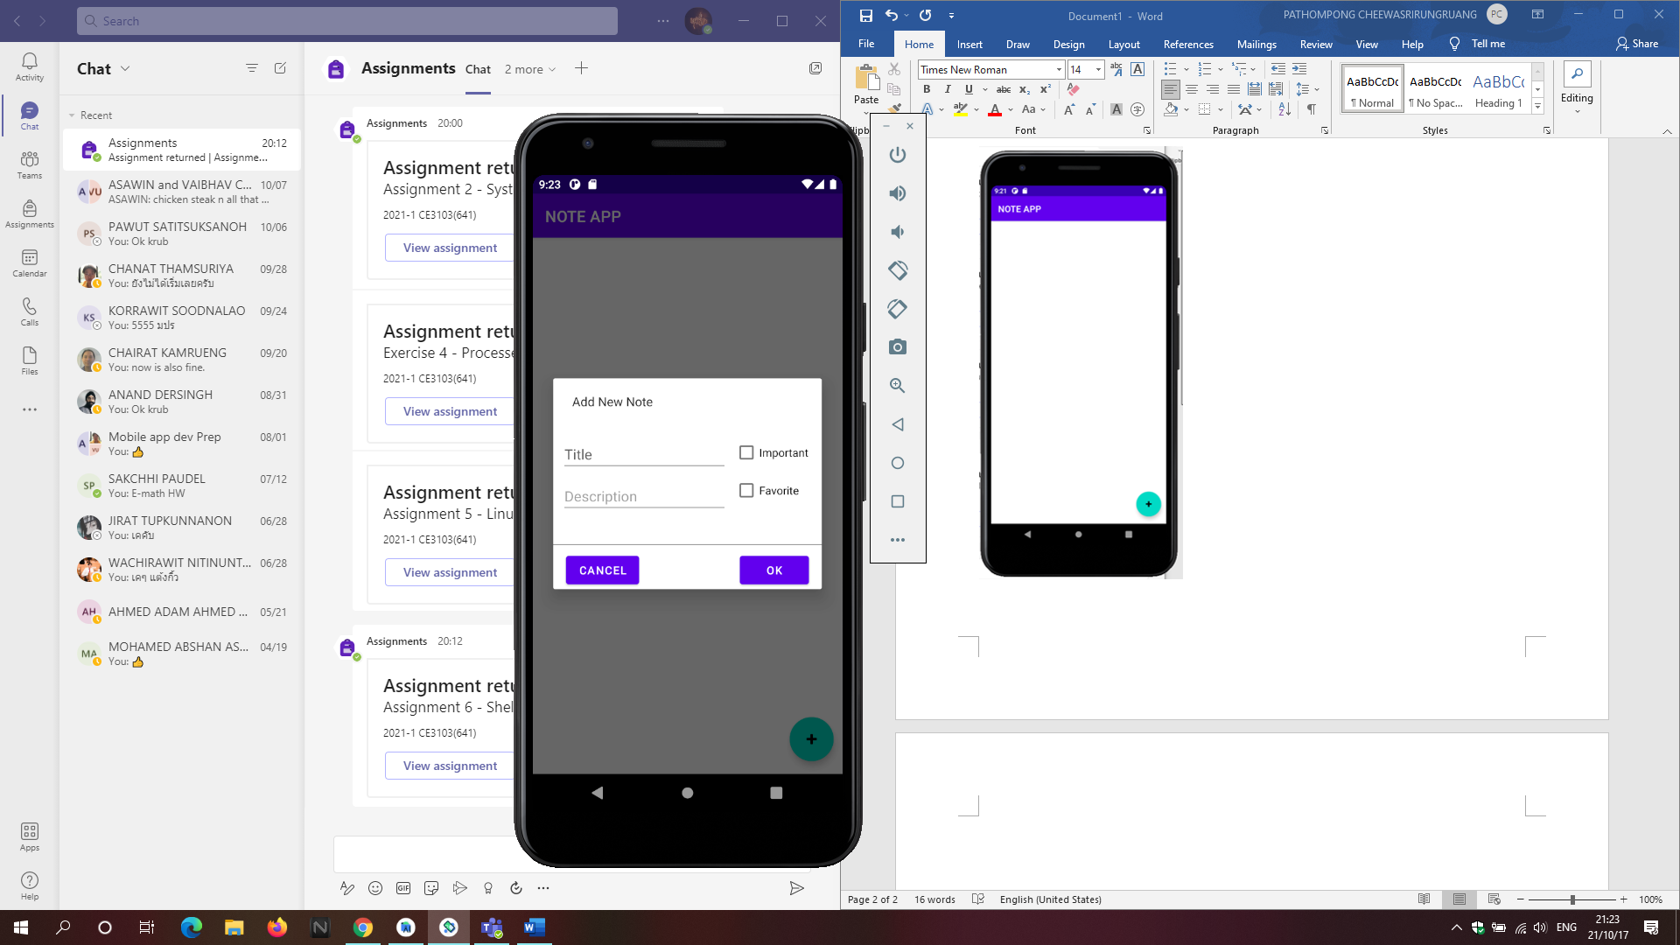

Upon pressing the Floating Action Button a New Note dialog is shown, the user is the able to fill in the space provided, as well as pick if its important or if it’s a favorite.

When pressing the OK button after filling in the fields. The value is then saved into the Note class, and added to the arrayList via createNewNote function found on the MainActivity.

Pressing Cancel will simply dismiss it.

Adding Input & Result

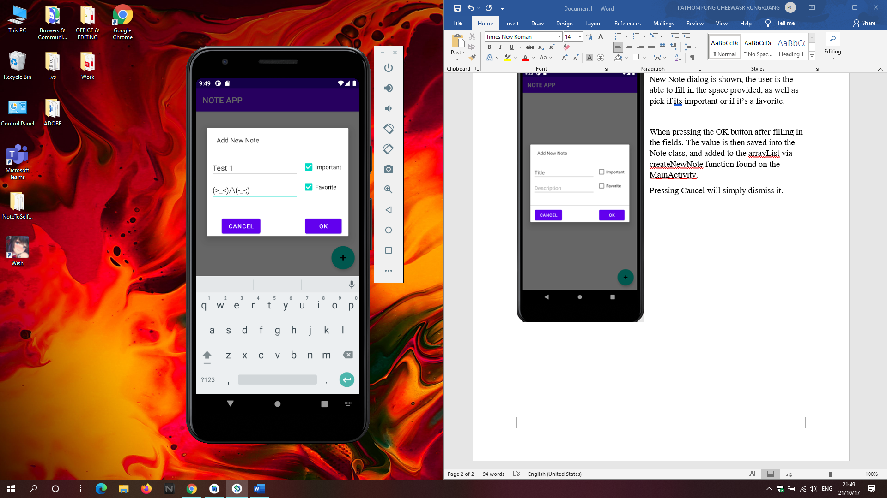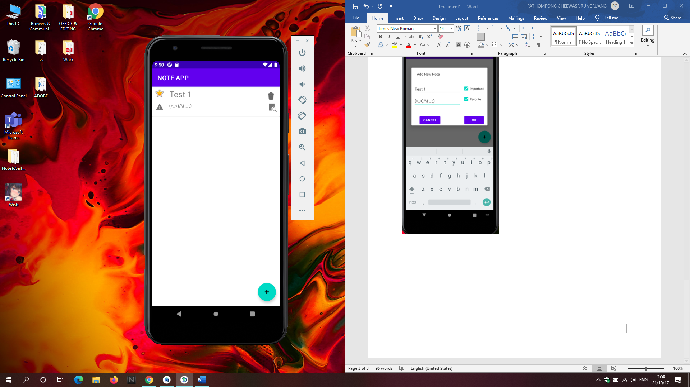

More Inputs

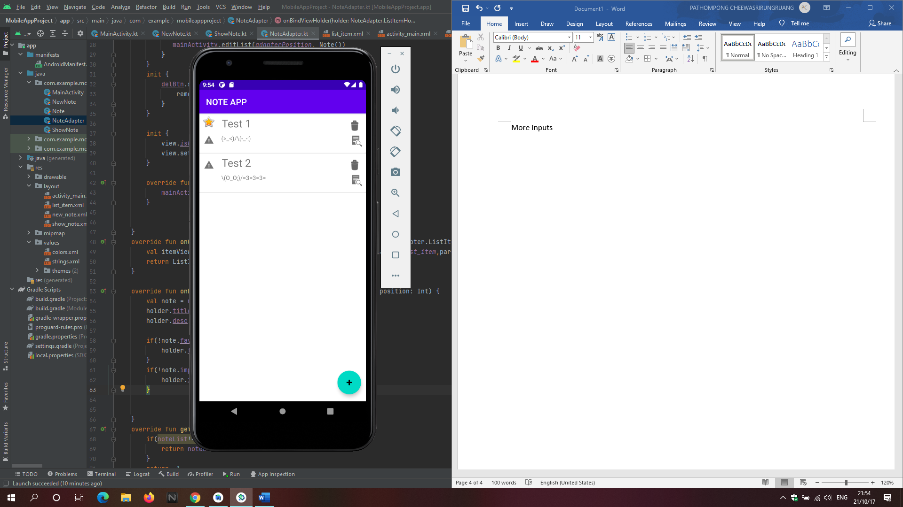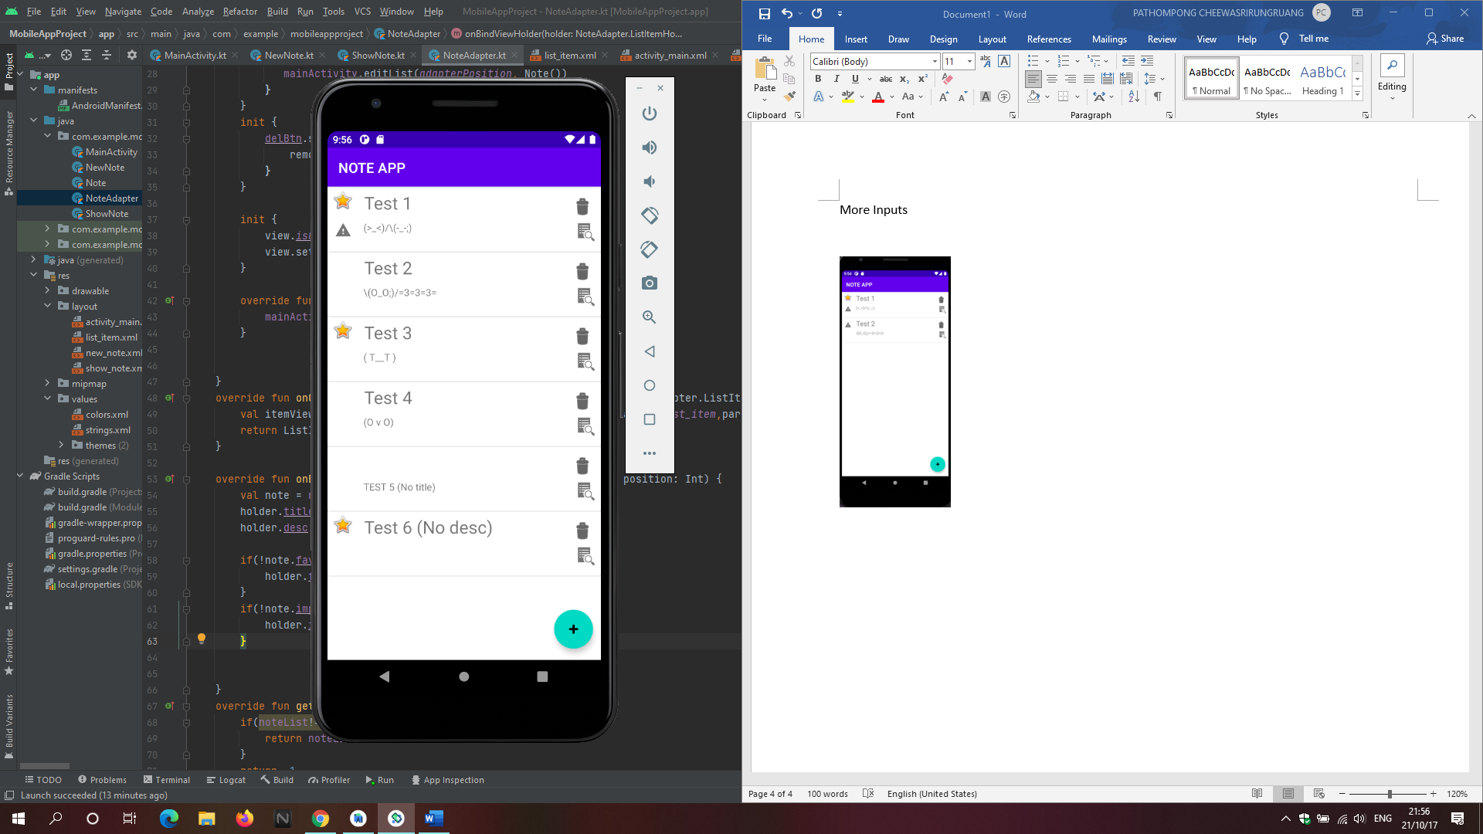

Known bugs:

Adding too many notes may cause the Favorite Icon(Star) and Important Icon (Alert Mark) to disappear.

Pressing On an item

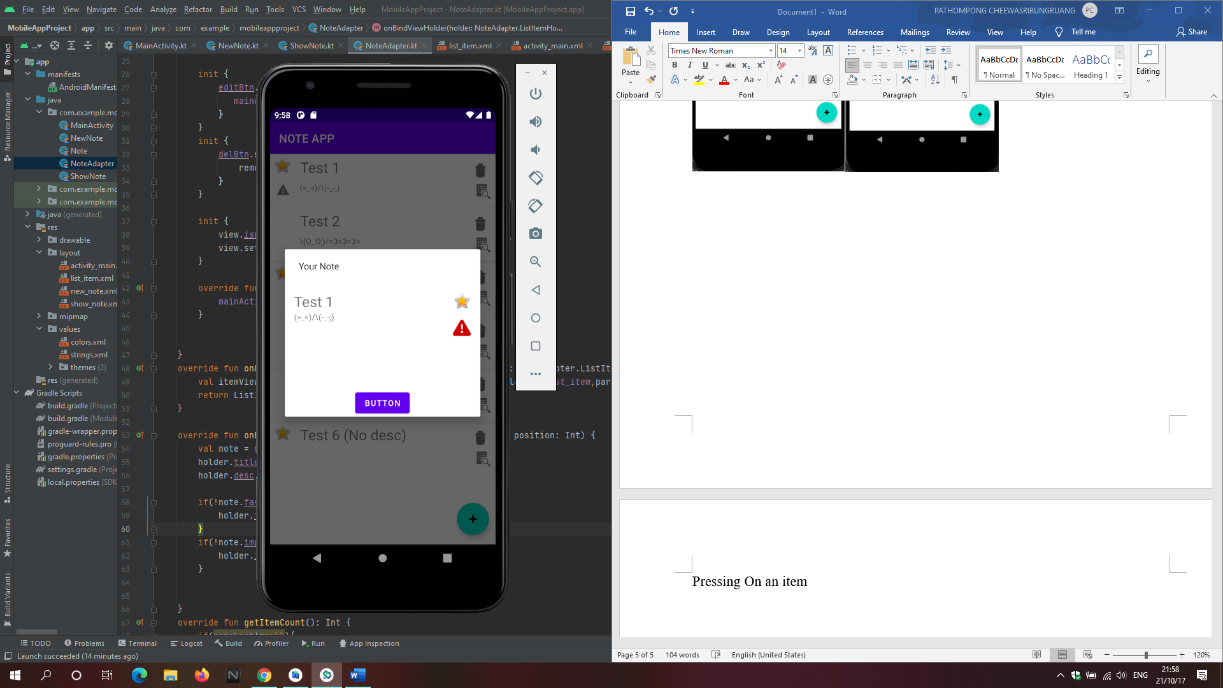

When pressing on an item the function showNote is called from MainActivity which has the gets the position of the item pressed passed on as a parameter.

The dialog then shows the content of the item pressed.

Other items

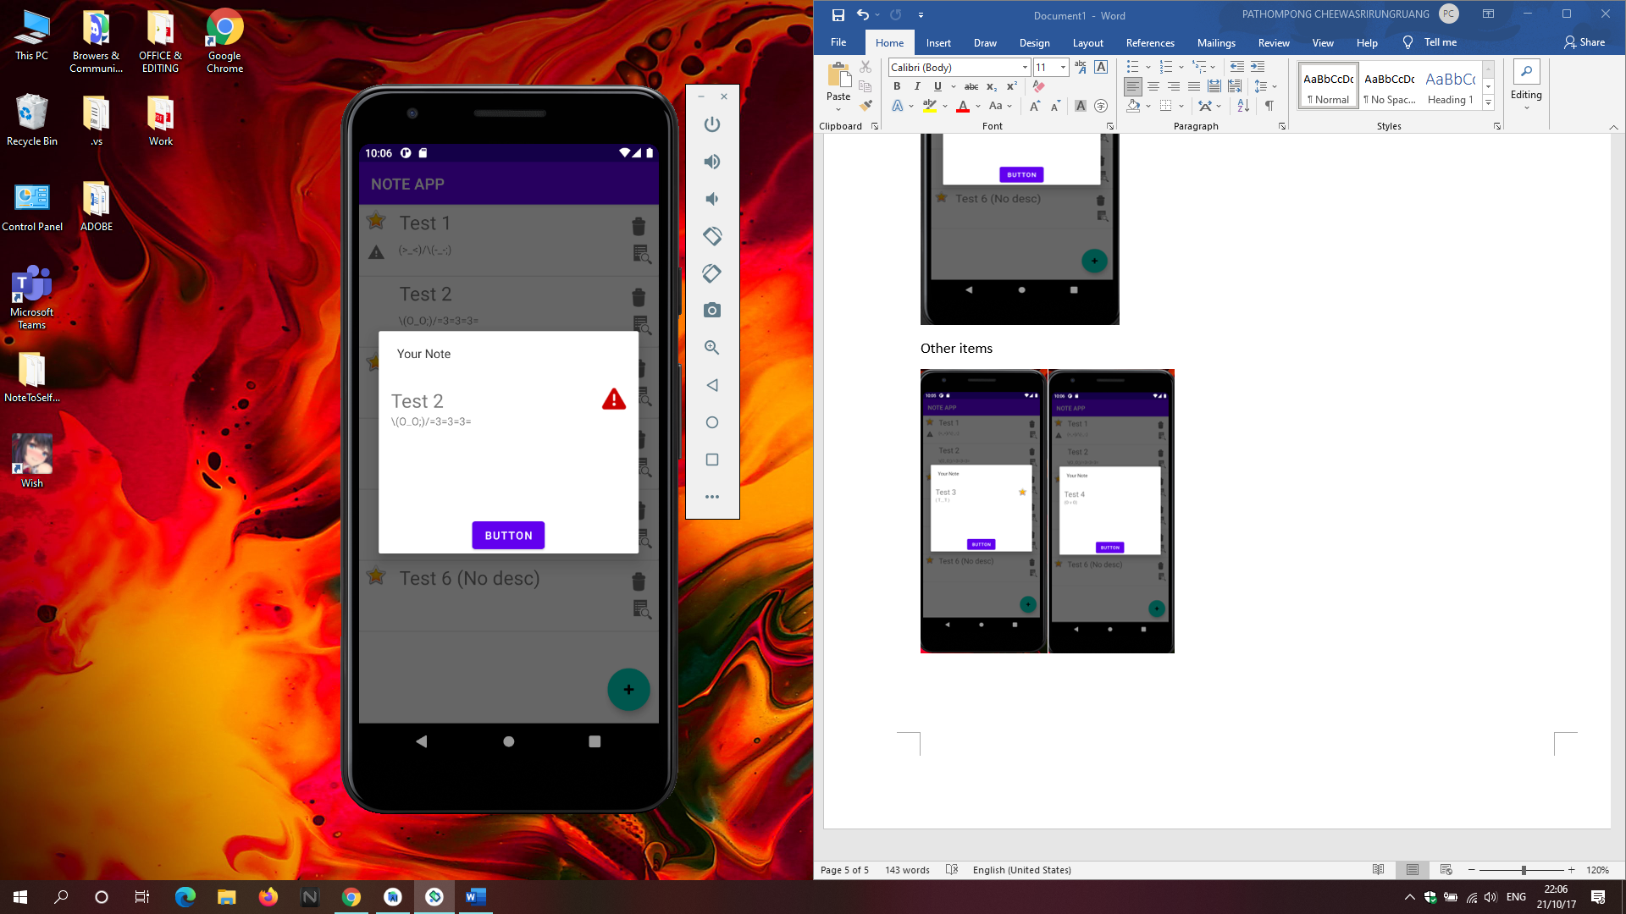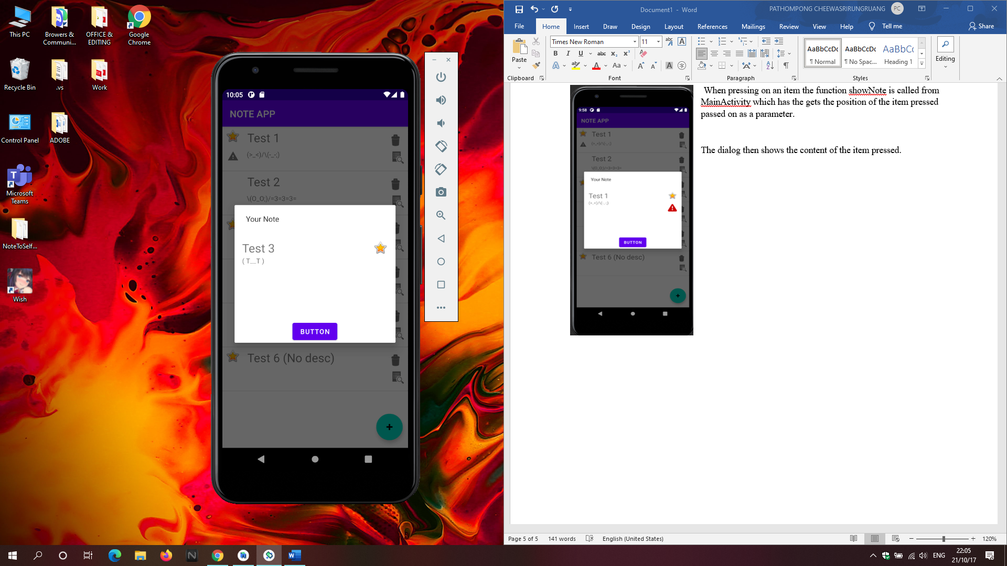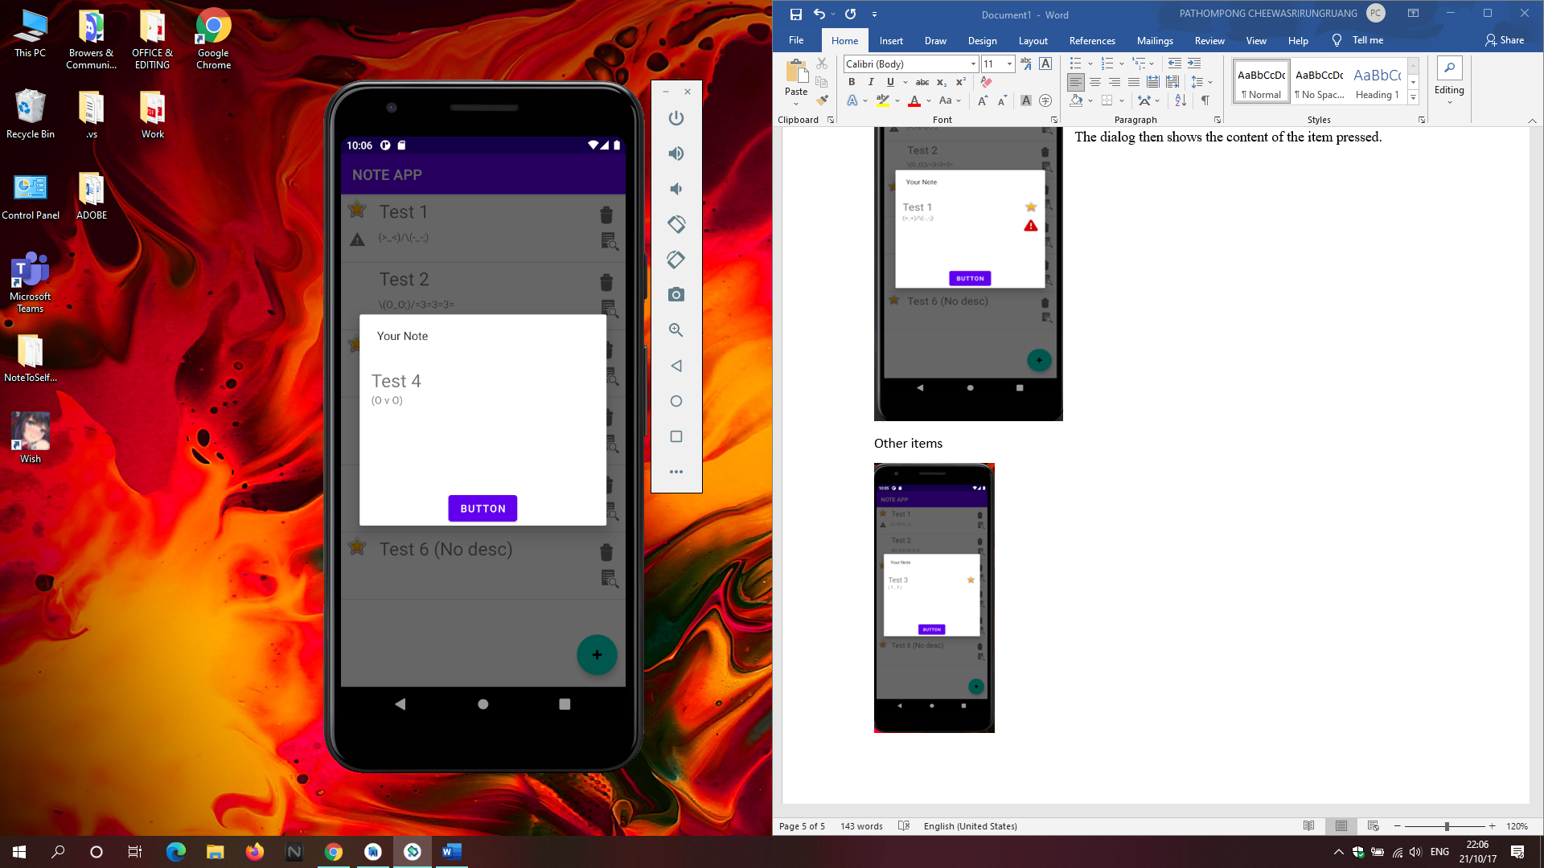

Deleting Note:  
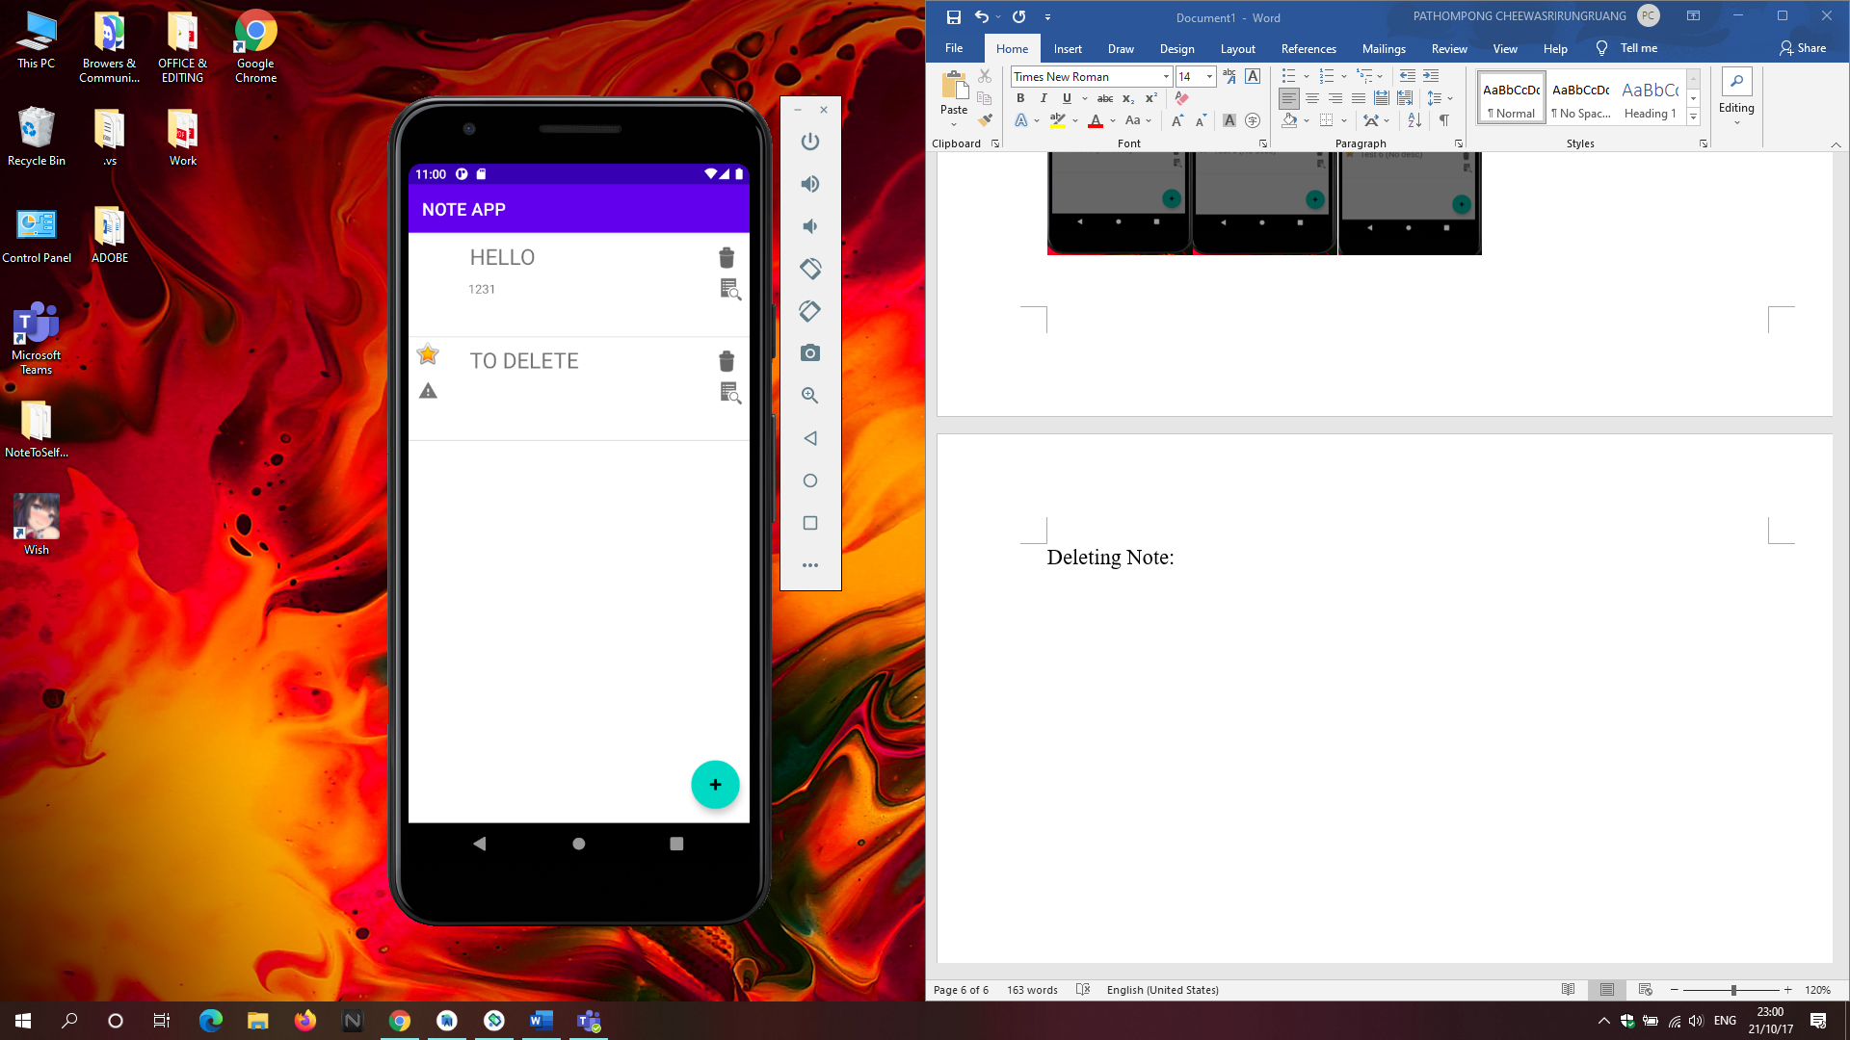

The button is set as clickable. And when pressed a function removedFromList is called from mainactivity, which takes the adapterPosition as a parameter.

The item is removed from the noteList arrayList and when it is removed, we also notify the adapter that the item is removed.

Know Bugs:

After pressing delete the item in the list is moved as shown in the picture below. Adding a new note will fix it temporarily (until an item is deleted again)

To delete the note.

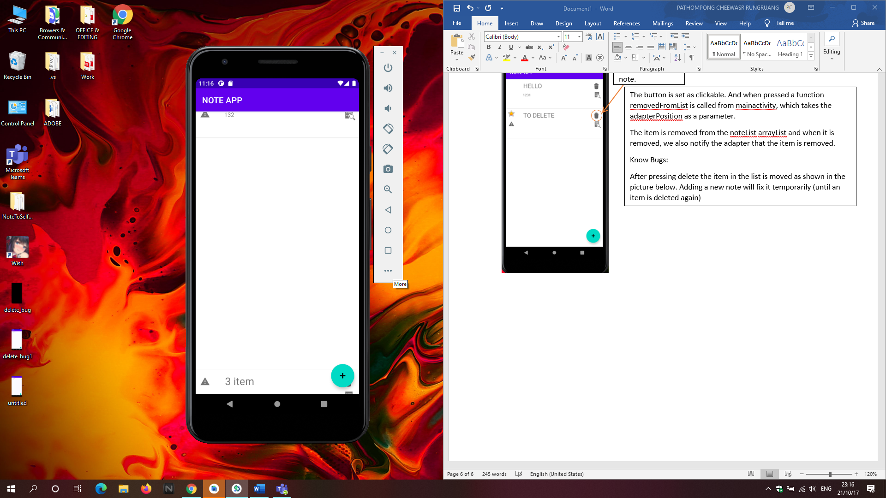

EDIT

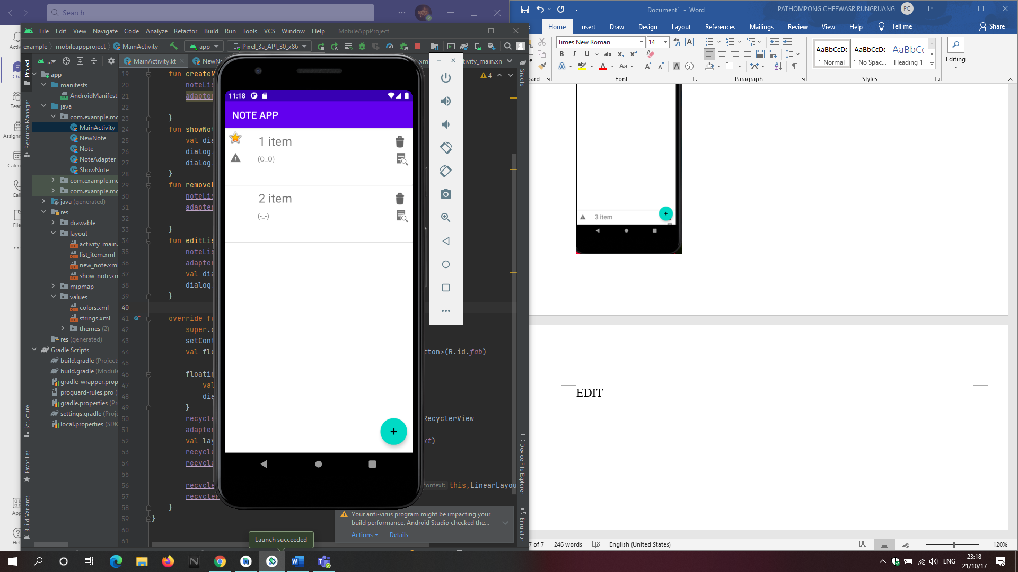

I wasn’t able to make it editable, instead this will remove the item and ask the user to create a new note.

The button was set as clickable, when pressed it calls editList function, and similar to removeList uses the adapterPosition as a parameter. To remove it from the arrayList, and adapter is notified of the item removed. Then a new note dialog is shown.

Issues:

The newly created note won’t replace the item at the same position.

Edit Item

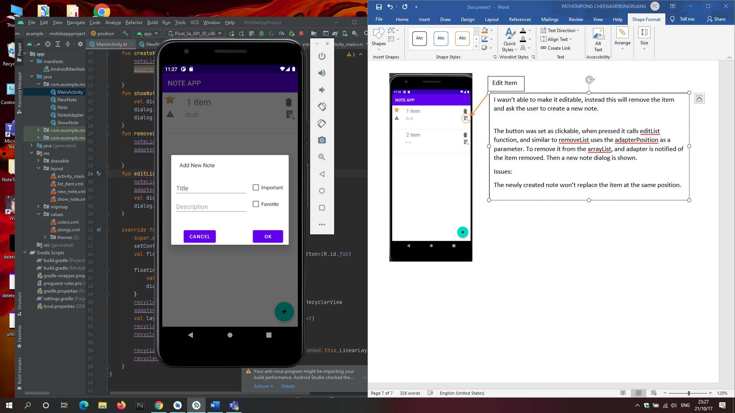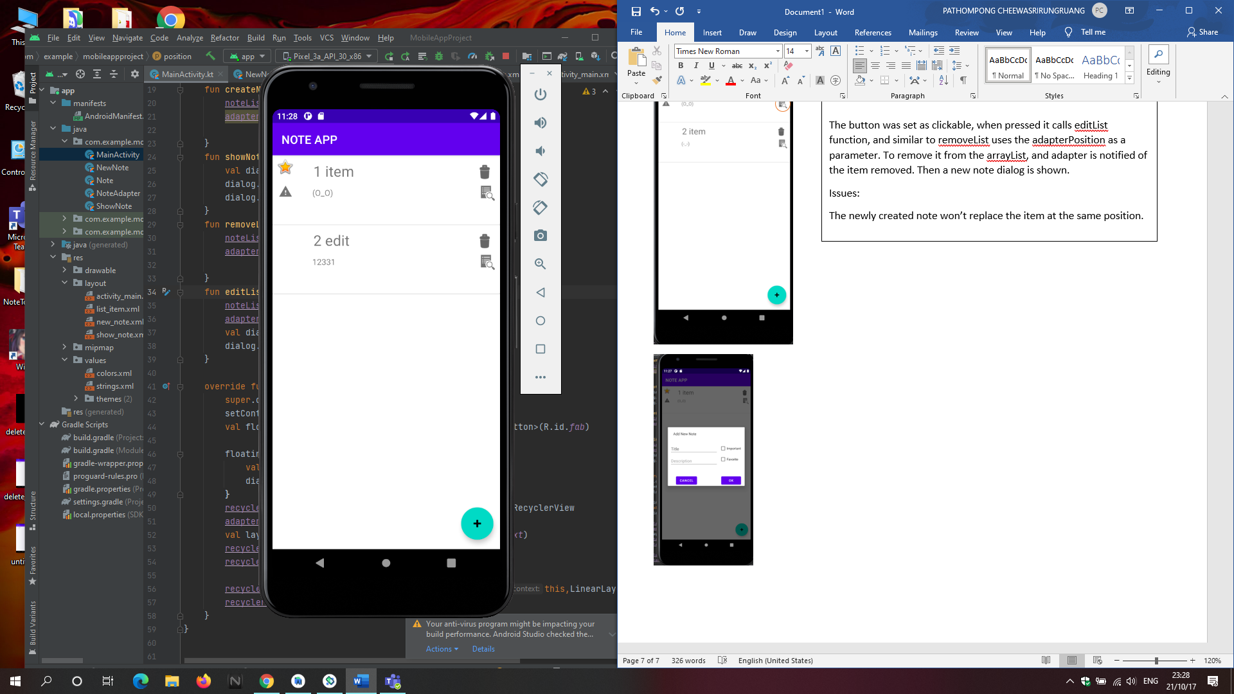

TEST CASES

|  |  |  |  |
| --- | --- | --- | --- |
| Condition | Expected Result | Result | Pass/Fail |
| Add note to Recycler view | After Ok button is pressed in New Note Dialog. It is added to the List | A new item is Added to the list | Pass |
| Delete Note from List | Selected Item is removed from the list | The selected item is removed from the list | Pass |
| Edit List works | Selected Item is removed and a new one is added | A new item is added and a new item is added | Pass |
| List is Save after reopening app | All of the list added is there when opening the app again | Item is not saved. | Failed/ Not implemented |
| All inputted data is shown when viewing it (show note dialog) | All inputted data appropriately appear in the show note dialog | Inputted data is shown | Pass |
| Adding a lot of items to the list | Data is displayed correctly in the recycler view | Favorite Icon and Important Icon may disappear when adding many items to the list. | Fail |